MOPS REGISTRATION
Name:
Address:

City/Zip:
Phone:
E-mail Address:
Birth date:
Church Affiliation, if any:

Names and birth dates for ALL your children:

SERVICE OPPORTUNITIES
Your registration fee covers all morning activities for MOPS and MOPPETS - including crafts, childcare, special guest speakers and demonstrations. However, all moms are asked to help with simple food for hospitality involvement in set-up and teardown tasks.

The MOPS leadership team provides a special opportunity for service and spiritual growth. Make your MOPS experience even more rewarding by getting involved! Please circle all areas you might like to serve in:

⬧ MOPPETS Curriculum  Hospitality Team 
⬧ Special Events  Craft Team 
⬧ Publicity  Small Group Leader 

MOPS is successful because of YOU! Thank you in advance for your participation and eager involvement!

MOPPETS REGISTRATION

Mom’s Name:

Are you currently pregnant?
If so, when is your due date? ___/___/___.

Children’s Information:

Register only those who will be 4 mos. old
by the start date of MOPS.
(Children younger than 4 months can stay with mom.)

1. Child’s name:
- Male - Female
Date of Birth: _______/_______/________
Special Instructions:

2. Child’s name:
- Male - Female
Date of Birth: _______/_______/________
Special Instructions:

3. Child’s name:
- Male - Female
Date of Birth: _______/_______/________
Special Instructions:

Emergency Contact Information:
Name:
Phone #:
Cell #:

MOTHERS OF PRESCHOOLERS

MOPS provides a God-centered, caring ministry for mothers of preschoolers, designed to nurture and encourage young mothers who are in this unique season of life by:

⬧ Creating an atmosphere of encouragement and acceptance.
⬧ Developing a sense of community to family, other women, church and community.
⬧ Providing opportunities for growth in self-worth and confidence.
⬧ Encouraging the discovery that God is relevant to each woman’s everyday life.
A MOPS morning is filled with fun surprises, informal refreshments, speakers, meaningful small group discussions, and creative crafts.
The MOPPETS program provides loving infant and toddler care. Loving caregivers provide activities that contribute to the child’s:

⬧ Social growth through play and participation.
⬧ Physical and creative development through games, crafts, and exercise.
⬧ Spiritual enrichment through musical Bible stories that are relevant to children’s lives.

Every MOPPETS morning is filled with stories, games, songs, crafts, art projects, and play time for your child.

THE DETAILS...

Fall Schedule 2016
Thursdays, 9:00am - 11:30am
Sep 15, 22, 29 - Oct 6, 13, 20
Nov 3, 17 - Dec 1, 15

REGISTRATION FEES
(Fall 2016)
Mom only: $100.00
Mom w/ 1 child: $130.00
Mom w/2 children: $160.00
Mom w/3+ children: $175.00

Cancellation Policy: Up to two weeks before the beginning of MOPS session, your fees (less $20) may be refunded.
No refunds after the program begins.

TO REGISTER: Space is limited. Registration is based upon an availability basis. Register before spots are filled! Please complete forms and mail with your check payable to:
Our Savior’s Lutheran Church
Memo Line: MOPS
Mail to:
Our Savior’s Lutheran Church
Attn: MOPS
200 Avenida San Pablo
San Clemente, CA 92762

Our Savior’s Lutheran Church & School
200 Avenida San Pablo
San Clemente, CA 92762

Our Savior’s
Lutheran Church

Mothers of
Preschoolers

INFORMATION & REGISTRATION
Fall 2016
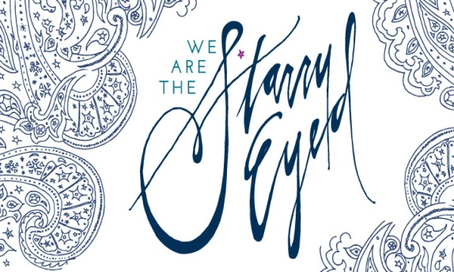

A program designed especially for you, with a special time of fun
for your little ones!

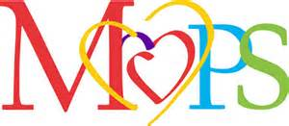

Kelly Frohner (949) 361-2331 andrewsmom@prodigy.net

